MegaSeg Basics

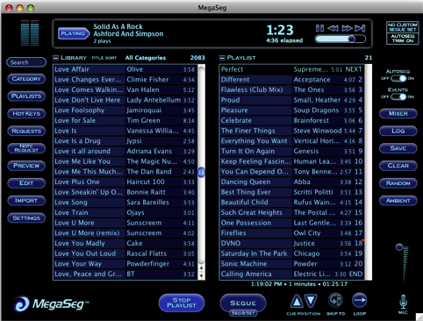
MegaSeg with mixer hidden

There are 2 lists on your screen: on the right is the library and on the left is your playlist. The bar on top displays the song currently playing.

Library

The list on the left displays your music library. At the top of the list, to the right of the word Library are two text buttons. Click “Title Sort” to change the way tracks are sorted in your library. You can sort by title, artist, album, beats per minute (BPM), play count, time, date added and folders.

Click “All Categories,” or the “Category” button on the left side of the screen to bring up the category browser. Click a category to display all the songs in that category, by default all the categories are shown.

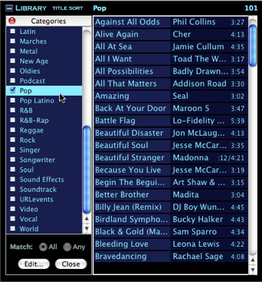

Library with category browser open

You can select songs in multiple categories. When more than 1 category is selected there are options (at the bottom of the category browser) to match “Any” or “All of the categories in your list. Selecting “Any” will display tracks that match any checked items in the category list. Selecting “All” will display only tracks that have been assigned multiple categories that match all of the checked categories. Click “Close” to close the category browser.

Above the library to the right, Megaseg displays the total number of tracks in the current list. Megaseg also lets you customize the way the Library and Playlist displays information. You can display 1, 2, or 3 rows of information per track by clicking the small square button to the top left of the Library or Playlist. You can search the library using the search box to the left of the Library.

Playlists

The list on the right side of the screen is the playlist. On the top right of the playlist, Megaseg displays the number of tracks in the current playlist.

- Adding tracks: to add tracks drag them over from the library. You can also double click a song in the library to add it to the bottom of the playlist, or hold down the “Option” button while you double click to add the song to the top of the playlist.

- Rearranging tracks: Drag a song to move it up or down in the playlist. Double click a track in the playlist to move it to the top of the playlist.

- Removing tracks: Dragging a track from the playlist back towards the library will remove it from the playlist.

- Adding breaks: Click the “Break” button on the bottom of the playlist to stop the current playlist. This will automatically add the break to the top of the playlist and will start it after the current track is finished playing. You can drag a break to place it anywhere in the playlist. Press the “Segue” button at the bottom center of the screen to end your break and start the next track in the playlist.

- Segue: to skip from the currently playing song to the next one cued up, press the “Segue” button at the bottom center of the screen. It will automatically fade out from one song into the next.

- AutoSeg: to the right of the playlist is the “AutoSeg” button. If it is turned on, the last 7 seconds of the song currently playing will fade into the next song, creating a smooth transition. If it is off, the songs will not fade into each other, creating a rough transition.

To the right of the playlist are “Clear” and “Random” buttons. Clear will remove all the songs in the current playlist and random, will shuffle the playlist.

At the bottom of the playlist window are 3 numbers that display information about the current selected track in the playlist (click a track once to select it). The first number is the time when the selected track will start playing. The second is the minutes away the scheduled track will play and the third is the total playlist time of all the tracks cued.

At the bottom of the screen, underneath the playlist, are the buttons: “Cue Position,” “Break,” “Skip To” and “Loop.”

- Cue Position moves the playlist forward or back one song for every click.
- Break stops the current playlist until you press the “Segue” button at the bottom of the screen.
- Skip to: moves the playlist forward to cue up the selected song
- Loop: when this button is turned on it will put the current playlist on repeat. If the button displays a circular arrow, loop is turned on If it displays a straight arrow, pointing to the right, loop is turned off.

Preview, Mic and Requests

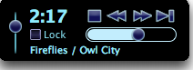
Preview playback controls

- Preview: Click this button, on the left hand side of the screen, to preview any song selected in the library. When a song is being previewed, a preview box appears in the bottom left hand corner of the screen with playback controls. When “Preview” is on, you can click any other track and it will instantly switch to preview the selected track. To prevent this from happening, press the “Lock” checkbox above the title in the “Preview” playback options.

- Requests: MegaSeg includes a separate Request List which allows you to note requests from any Library or Playlist display list using the “Note Request” button. A dialog window will appear with the option to add a text message you want to have displayed when the song is cued up in the Next position of the Playlist.

Once you have noted some requests, press the “Requests” button to display your Request List in the Library display. You can add songs from the Request list into the Playlist the same way you songs from the regular Library list. To clear a request from the list, press the Delete key, or use the Remove Request button. You can return to the full Library from the Request list by pressing Request at the top of the Library window.

When songs are added to the Playlist, they are automatically removed from the Request List. Also, the Request list will not let you add duplicates to the list. When a requested song is cued in the Next position, if you added a text message to the request, a window will pop-up to display your message.

Mixer Basics

Press the “Mixer” button on the far right hand corner of the screen to display or hide the Mixer. The Mixer allows you to mix mp3 tracks. The right side of the Mixer (Current Deck) displays the song now playing; the left side (Next Deck) displays the song that is cued up to play next.

Note: for a more advanced explanation of the mixer, see the MegaSeg manual.

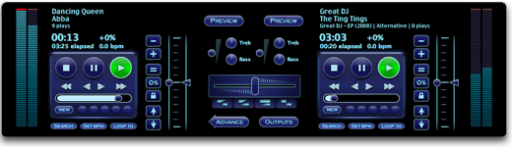
The Mixer

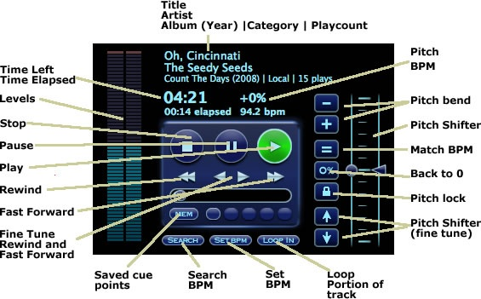

Working with BPM

The mixer assists in beat matching when the BPM (beats per minute) values for the 2 songs are set.

Set BPM: Click the “Set BPM” button to bring up the BPM Tapper. Click the mouse of press the spacebar 17 times to the beat of the songs to set the BPM. If you get off beat, press “Reset” to start again or “Cancel” to close the window.

Search BPM: click the “Search BPM” button to find tracks in the Library with similar BPMs.

Match BPM: Click the equals (=) button on either deck to automatically match the BPM and pitch on its deck to the other deck’s BPM. The beat match will be a close approximation based on the BPM values.

Pitch Shifting

Pitch Shifter: Use the pitch shifter to speed up of slow down a song. This will change both the tempo (speed) of the song and the pitch (how high or low it sounds). You can also make fine-tuned adjustments of the pitch using the buttons with up or down arrows. Use the 0% button to automatically reset the pitch to 0.

Pitch lock: Use the button with the lock sign, to keep the pitch the same while you use the pitch shifter to adjust the speed.

Pitch bend: Use the Pitch Bend buttons (+ / -), to temporarily speed up or slow down a song, this is helpful when trying to fine-tune a beat match of two songs, so that the beats play at the same time.

Cross-fading

Cross-fading: Slide the cross-fader to mix or fade back and forth between the tracks in the Next Deck and the Current Deck.

Advance: When the cross-fade is complete, use the “Advance” button to advance the Playlist. This shifts the tracks from the Next Deck to the Current Deck.

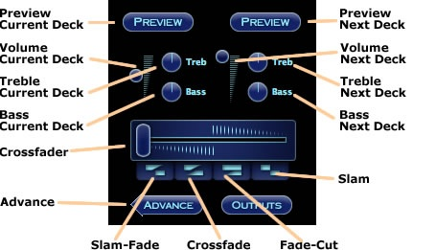

Special Cross-fades: MegaSeg has 4 special cross-fades.

- Slam-fade: The most common way to start a new song. It will start the Next song full volume and start fading the Current song out smoothly.

- Crossfade: will fade in the Next track and then fade out the Current track.

- Fade-Cut: requires 2 clicks. When first clicked, it starts to fade in the Next track, then waits while the Crossfader is in the middle and both tracks are playing at full volume. Then on the second click, it sharply cuts out the Current song. This is a common cross-fade move when beatmixing, when you want to cut the last song out right after they play together for a measure or two, for example.

- Slam: slams the Crossfader to the opposite side it’s currently on, causing a sharp cut between the decks.

Loops and Cue Points

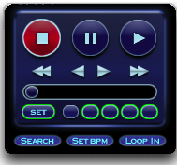

Creating Cue points: To create a cue point, play a song and press “Pause” where you would like the cue point to be. Use the Stutter buttons (the fine tune rewind and fast forward) to fine tune your cue point to exactly where you want it. Then press “Stop” to lock in that cue point.

Saving Cue Points: There are a row of 5 memory buttons at the bottom of the deck’s transport controls. These can be set at any time by clicking the “Set” button to the left, and then clicking the “Mem” button to store the current cue position. You can delete a memory position by clicking “Set” twice to put it into delete mode.

Loop in: The “Loop In” button triggers MegaSeg’s looping feature, and marks the start of a loop. You can press this in real-time while a track is playing, or while in pause mode. After pressing “Loop In,” the button changes to “Loop Out,” which will mark the end of the loop when clicked. If it is playing in real time you will now hear it looping the section of the track over and over. The button will now change to “Loop Exit.” Clicking that will clear the loop and allow the track to play through to the end, or until you start another loop.

